UNITED STATES
SECURITIES AND EXCHANGE COMMISSION
Washington, D.C. 20549

FORM 6-K

REPORT OF FOREIGN PRIVATE ISSUER
PURSUANT TO RULE 13a-16 OR 15d-16
UNDER THE SECURITIES EXCHANGE ACT OF 1934

For the month of October 2026

Commission File Number: 001-42551

SAGTEC GLOBAL LIMITED
(Registrant’s Name)

Lot 6-2, Level 9, Equatorial Plaza,
Jalan Sultan Ismail, 50250 Kuala Lumpur, Malaysia
(Address of Principal Executive Offices)

Indicate by check mark whether the registrant files or will file annual reports under cover Form 20-F or Form 40-F.

Form 20-F ☒ Form 40-F ☐

On October 8, 2026, CL Technologies (International) Sdn. Bhd., a wholly owned subsidiary of Sagtec Global Limited (the “Company”), changed its corporate name to CLAI Tech Sdn. Bhd. (the “Subsidiary”). The change of name was registered in Malaysia under the Companies Act 2016 and is evidenced by a Certificate of Incorporation on Change of Name of Company dated October 9, 2026. The Subsidiary was incorporated in Malaysia on February 14, 2019 under registration number 201901005005 (1314332-U).

The name change aligns the Subsidiary’s corporate identity with the Company’s CLAi artificial intelligence technology platform and its focus on artificial intelligence and enterprise technology solutions. The name change does not alter the Subsidiary’s ownership, management, existing contractual obligations or business operations. The Company will continue to operate as Sagtec Global Limited, and its ordinary shares will continue to trade on the Nasdaq Capital Market under the symbol “SAGT.”

On October 13, 2026, the Company issued a press release announcing the change of name of the Subsidiary.

A copy of the Certificate of Incorporation on Change of Name of Company is furnished as Exhibit 99.1 to this Report on Form 6-K. A copy of the press release is furnished as Exhibit 99.2 to this Report on Form 6-K.

EXHIBITS

Exhibit 99.1 |  | Certificate of Incorporation on Change of Name of Company dated October 9, 2026, relating to CLAI Tech Sdn. Bhd.
Exhibit 99.2 |  | Press Release dated October 13, 2026, titled “Sagtec Global Announces Successful Corporate Name Change of Subsidiary to CLAI Tech Sdn. Bhd.”

1

SIGNATURES

Pursuant to the requirements of the Securities Exchange Act of 1934, the registrant has duly caused this report to be signed on its behalf by the undersigned, thereunto duly authorized.

SAGTEC GLOBAL LIMITED
By: | /s/ Ng Chen Lok
Name: | Ng Chen Lok
Title: | Chairman, Chief Executive Officer and Executive Director

Date: October 13, 2026

2

Exhibit 99.1

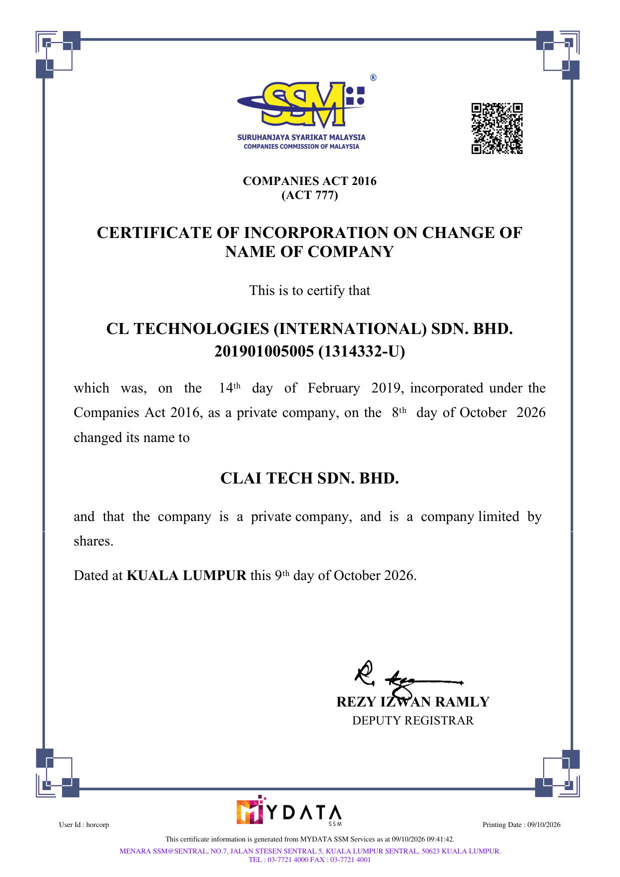
COMPANIES ACT 2016 (ACT 777) CERTIFICATE OF INCORPORATION ON CHANGE OF NAME OF COMPANY This is to certify that CL TECHNOLOGIES (INTERNATIONAL) SDN. BHD. 201901005005 (1314332-U) which was, on the 14ᵗʰ day of February 2019, incorporated under the Companies Act 2016, as a private company, on the 8ᵗʰ day of October 2026 changed its name to CLAI TECH SDN. BHD. and that the company is a private company, and is a company limited by shares. Dated at KUALA LUMPUR this 9ᵗʰ day of October 2026. REZY IZWAN RAMLY DEPUTY REGISTRAR User Id : horcorp Printing Date : 09/10/2026 This certificate information is generated from MYDATA SSM Services as at 09/10/2026 09:41:42. MENARA SSM@SENTRAL, NO.7, JALAN STESEN SENTRAL 5, KUALA LUMPUR SENTRAL, 50623 KUALA LUMPUR. TEL : 03-7721 4000 FAX : 03-7721 4001
Exhibit 99.2

Sagtec Global Announces Successful Corporate Name Change of Subsidiary to CLAI Tech Sdn. Bhd.

Name change reflects the Group’s strategic transition towards AI-powered enterprise solutions and the continued development of the CLAi technology ecosystem

KUALA LUMPUR, MALAYSIA, October 13, 2026 (GlobeNewswire) – Sagtec Global Limited (“Sagtec Global” or the “Company”) (Nasdaq: SAGT), a technology solutions provider specialising in artificial intelligence software customisation, AI-assisted technology infrastructure and cloud-based digital solutions, today announced that its wholly owned subsidiary, formerly known as CL Technologies (International) Sdn. Bhd., has successfully changed its corporate name to CLAI Tech Sdn. Bhd. (“CLAI”).

The name change has been formally completed following the necessary corporate and regulatory procedures in Malaysia. It represents an important milestone in Sagtec Global’s ongoing transformation and reinforces CLAI’s strategic focus on artificial intelligence technologies, enterprise automation and intelligent digital solutions.

The rebranding follows Sagtec Global’s recent introduction of CLAi 1.0, its internally developed artificial intelligence platform designed to assist businesses and users across multiple digital functions. The platform brings together AI-powered capabilities including intelligent conversational assistance, software coding support, image creation, video generation, data analysis and business process automation within a unified environment.

By adopting the name CLAI Tech Sdn. Bhd., the subsidiary’s corporate identity is now more closely aligned with its principal technology platform and future business direction. The new identity is intended to support stronger market recognition of the CLAi brand as Sagtec Global expands its range of AI-driven products and services.

CLAI is expected to serve as a central platform for the Group’s AI research, software development, product integration and commercialization initiatives. In addition to offering CLAi as a standalone platform, Sagtec Global intends to progressively integrate its AI capabilities into the Group’s existing technology solutions, including its HALO AI-powered point-of-sale and human resources management systems.

The Group also plans to deploy CLAi’s capabilities across its existing business channels, including data analysis, data management, cloud infrastructure, social media management and customized enterprise software solutions. This integration strategy is intended to enhance automation, improve operational efficiency and create more intelligent and scalable solutions for customers across different industries.

The corporate name change does not alter the ownership, management, existing contractual obligations or business operations of the subsidiary. All existing agreements, commitments and business relationships entered into under the former name will continue to remain valid and effective, subject to the applicable terms and legal requirements.

Mr. Ng Chen Lok, Chairman and Chief Executive Officer of Sagtec Global, commented:

“The successful change of our subsidiary’s name to CLAI Tech Sdn. Bhd. represents more than a corporate rebranding. It reflects the strategic direction that we have established for the next phase of the Group’s development. Artificial intelligence is becoming increasingly central to how businesses operate, analyse information and engage with their customers, and we believe CLAi can play an important role in that transformation.”

Mr. Ng continued:

“Following the introduction of CLAi 1.0, we are now strengthening the corporate foundation behind the platform. By bringing the subsidiary and platform under a unified identity, we aim to build stronger brand recognition, accelerate the integration of AI into our existing products and develop new commercial opportunities in Malaysia and international markets.”

Sagtec Global believes that the transition to CLAI will support the Group’s long-term strategy of developing a broader AI technology ecosystem. This includes generating recurring revenue through platform subscriptions, enterprise licensing, software customization, system integration, cloud services, data management and ongoing technical support.

The Group intends to continue investing in the development and enhancement of CLAi’s capabilities, including solutions tailored to the operational requirements of businesses in retail, hospitality, human resources, data management and other enterprise sectors.

The name change applies specifically to the Malaysian subsidiary formerly known as CL Technologies (International) Sdn. Bhd. Sagtec Global Limited will continue to operate under its existing corporate name, and its ordinary shares will continue to trade on the Nasdaq Capital Market under the ticker symbol “SAGT.”

About Sagtec Global Limited

Sagtec Global Limited is a technology solutions provider specialising in artificial intelligence software customization, AI-assisted technology infrastructure, cloud-based digital solutions, data management and enterprise software development. Through its subsidiaries, the Company develops and provides technology solutions designed to improve operational efficiency, enhance business decision-making and support the digital transformation of enterprises.

For more information, please visit [www.sagtec-global.com].

About CLAI Tech Sdn. Bhd.

CLAI Tech Sdn. Bhd., formerly known as CL Technologies (International) Sdn. Bhd., is a subsidiary of Sagtec Global Limited focused on the development, integration and commercialization of artificial intelligence and enterprise technology solutions. Its core initiatives include CLAi 1.0, an all-in-one AI platform designed to support content generation, software coding, data analysis, intelligent assistance and business process automation.

For more information about CLAi, please visit https://cl-tech.com.

2

Forward-Looking Statements

This press release contains forward-looking statements within the meaning of applicable securities laws. These statements include, among other things, statements regarding the Company’s plans to develop, integrate and commercialize CLAi; expand its artificial intelligence capabilities; introduce new products and services; pursue business opportunities in Malaysia and international markets; and generate future or recurring revenue.

Forward-looking statements are based on the Company’s current expectations, estimates and assumptions and are subject to various risks, uncertainties and other factors that may cause actual results to differ materially from those expressed or implied in such statements. These factors include, but are not limited to, the Company’s ability to successfully develop and commercialize its technology, customer adoption of its products, competition, changes in market and economic conditions, regulatory developments and other risks described in the Company’s filings with the U.S. Securities and Exchange Commission.

Readers are cautioned not to place undue reliance on these forward-looking statements. The Company undertakes no obligation to update or revise any forward-looking statement to reflect subsequent events or circumstances, except as required by applicable law.

Contact Information

Sagtec Global Limited Contact:
Wan Najwa Enche Khawari
Head of Public Relations & Corporate Affairs
Telephone +6011-6217 3661
Email: info.pr@sagtec-global.com

3

